After Updates: Date:18/09/2024
Research Publication:
There are formatting issues.
Attachments are not showing in the backend.
Additionally, an extra field still exists. The field should be displayed as shown in the image below.
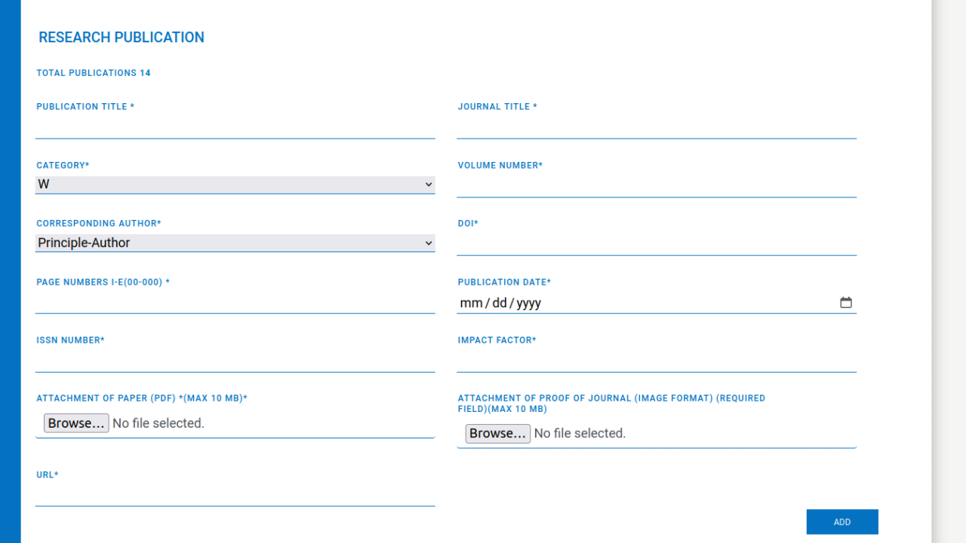

Supervision/Supervision List
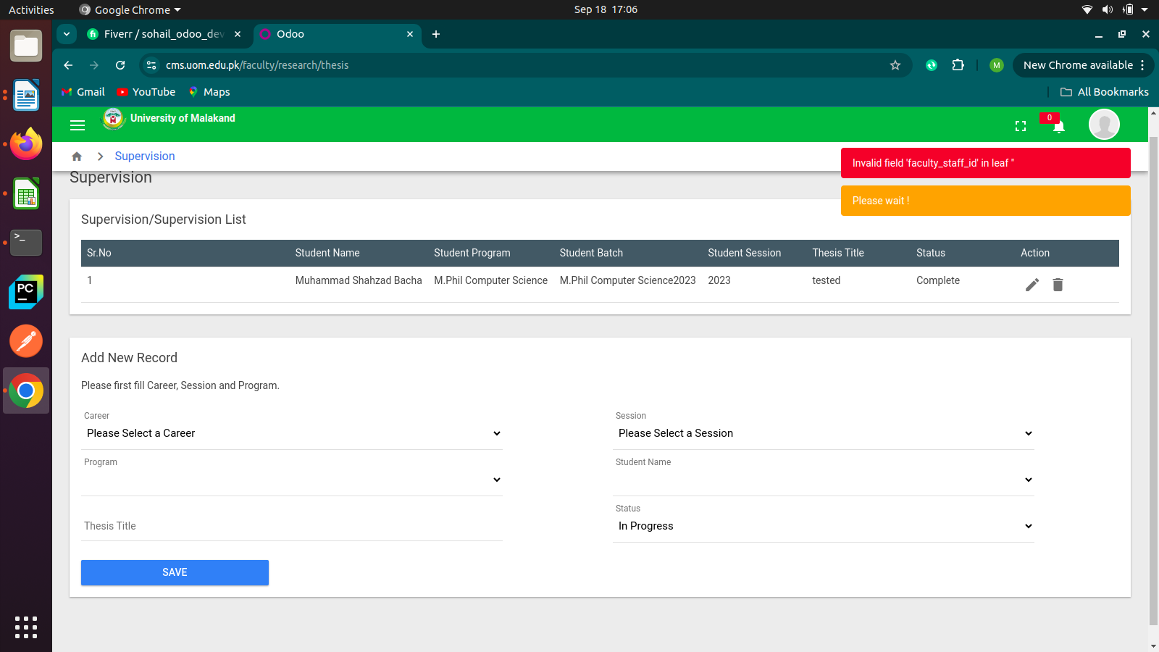
An error occurs while deleting a record from the Faculty Portal in Supervision.

Patent
The interface lack Field for Uploading the Proof.
The spelling of 'Patent' in the navigation bar needs to be corrected.
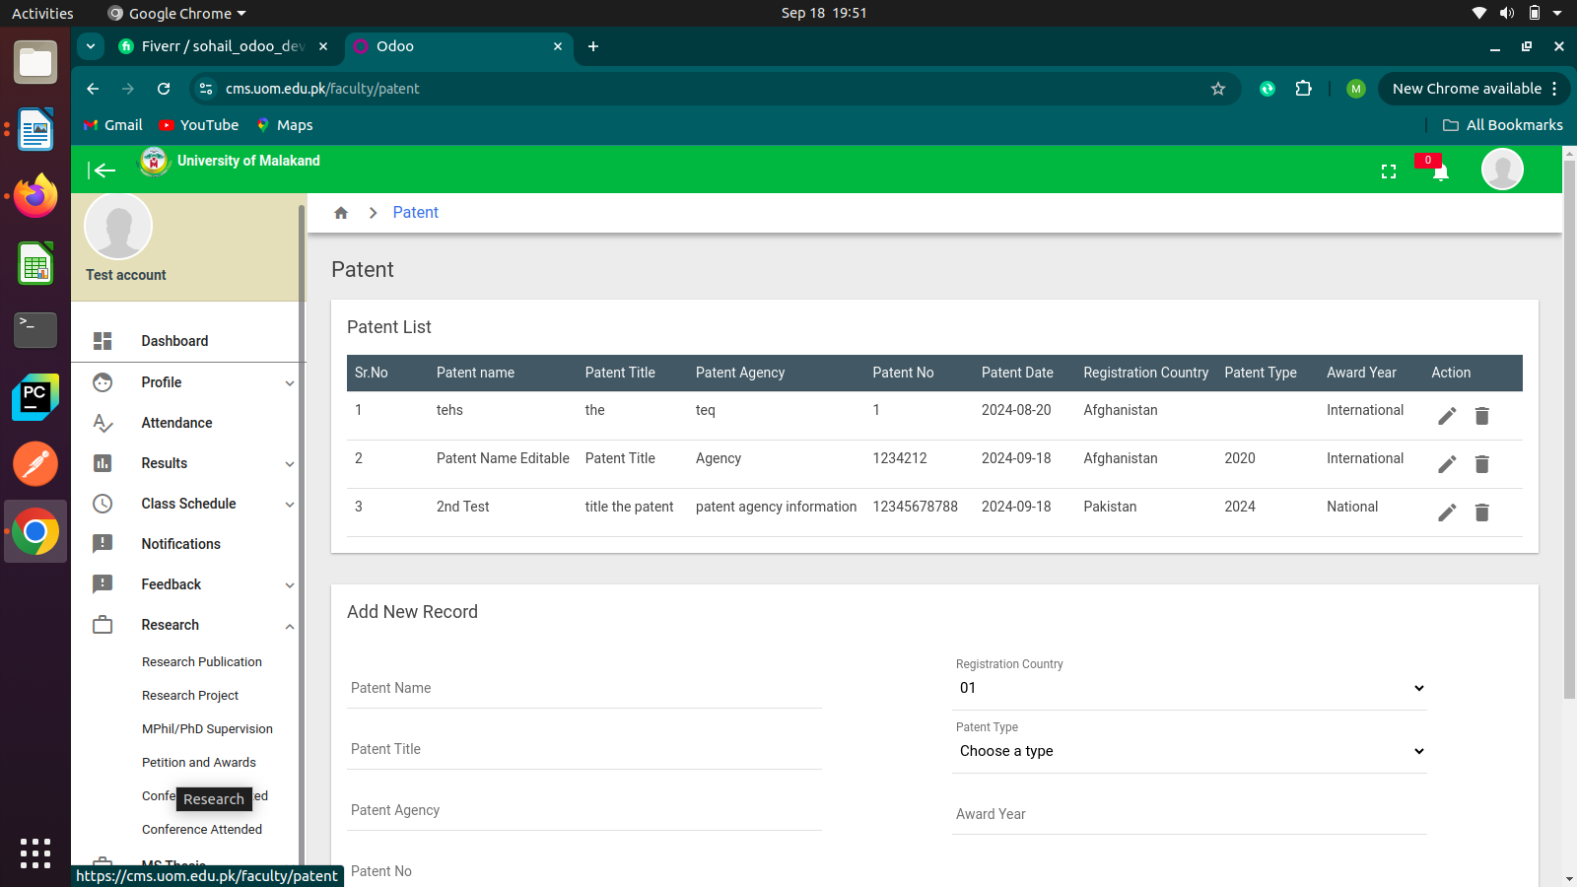

Conference/Workshop Organized:
The City Name field has been added twice in the backend.
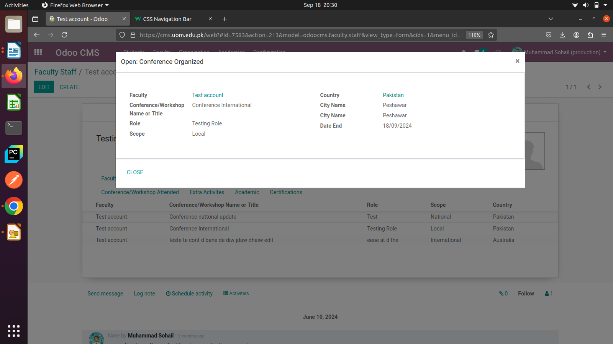
The start date is present on the Faculty Portal side but not in the backend.

Conference/Workshop Attended:
The City Name field has been added twice in the backend.
The start date is present on the Faculty Portal side but not in the backend.
